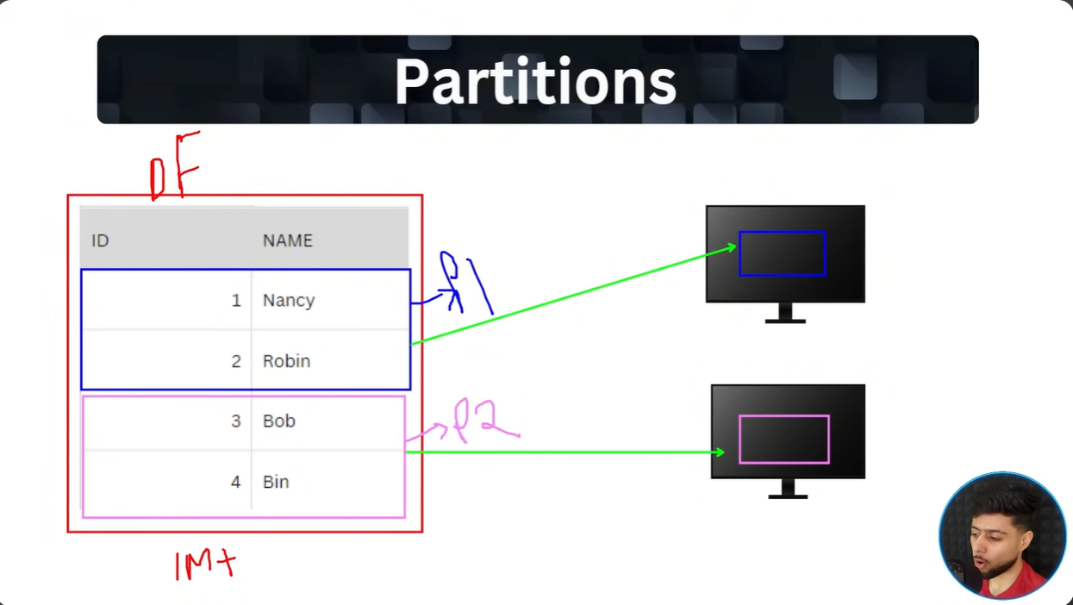
RDD(Redundant Distributed Dataset) is the list of logical partitions distributed across nodes(machines) containing executors.
